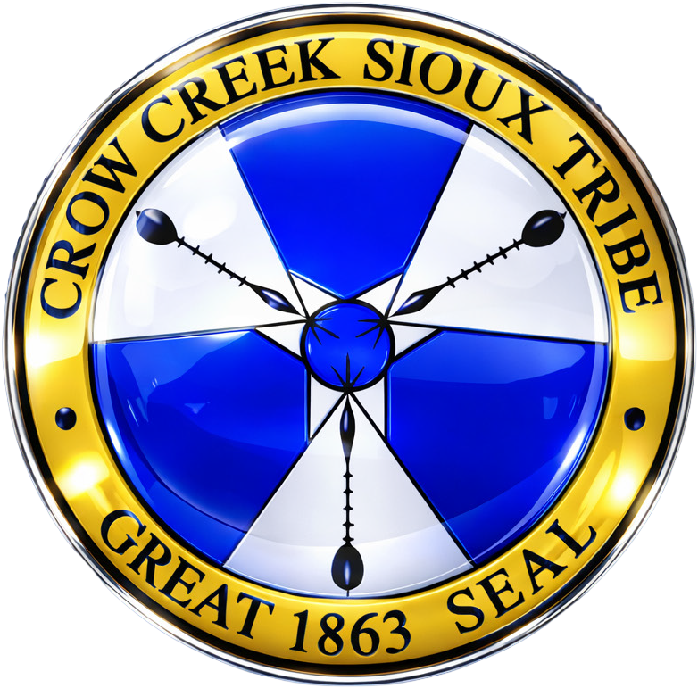
CROW CREEK SIOUX TRIBE

TRIBAL ENROLLMENT

Enrollment Eligibility
Article II of the Tribal Constitution and By Laws of the Crow Creek Sioux Tribe establishes the criteria for tribal membership.

MEMBERSHIP ELIGIBILITY:
- At least one of your biological parents must be enrolled member of the Crow Creek Sioux Tribe, AND
- You must possess: 1/4 or more SIOUX INDIAN BLOOD, or 1/2 or more INDIAN BLOOD.

REQUIRED DOCUMENTS:
- Completed Enrollment Applications.
- State-Issued Certified Birth Certtificate (ORIGINAL OR COPY)

OTHER REQUIRED DOCUMENTS IF APPLICABLE:
- Paternity: A Paternity Affidavit signed by both parents or a DNA Paternity Test Result (ONLY if biological father is not listed on the birth certificate AND you want to include his Indian blood to calculate your degree of Indian Blood.
- Custody: Custody Court Order if only one biological parent is submitting an application on behalf of a minor child (informal agreements between parties not accepted).
- Guardianship: Guardianship court order for an application submitted on behalf of a minor by parties not the biological parents or on behalf of an adult with a guardian (informal agreements between parties not accepted).
- Adoption: Legal documents identifying biological parent(s) If applicant was adopted (Original birth certificate, adoption decree, etc.

APPLICATION PROCESSING
It is the Applicant’s responsibility to provide required documents to the Crow Creek Tribal Enrollment Office: Failure to do so will delay the processing of your application and possibly result in denial. We will contact other tribal enrollment offices for documentation if necessary. Once complete, your application will be provided to the Enrollment Committee for review and the Tribal Council for final determination. The entire process takes 1-3 months.

