Kangi Okute Ospaye of the Oceti Sakowin Oyate
Crow Creek Tribe of the 7 Council Fires Nation
Mdewakantunwan-Ihanktunwanna (Hunkpati)
Santee Yanktonai Dakota
Original Ihanktunwan Territory
South Dakota
North America
Maka Ina (Mother Earth)

The Crow Creek Tribe
Mdewakantunwan-Ihanktunwanna (Hunkpatina) Ospaye
are federally recognized tribe
based on the Crow Creek Dakota Reservation
located central South Dakota
On the east bank of the MniSosheh (Missouri) River

Made up of descendants of the
Mdewakantunwan (Minnesota Dakota)
Ihanktunwanna (Hunkpati) of the
Dakota People.

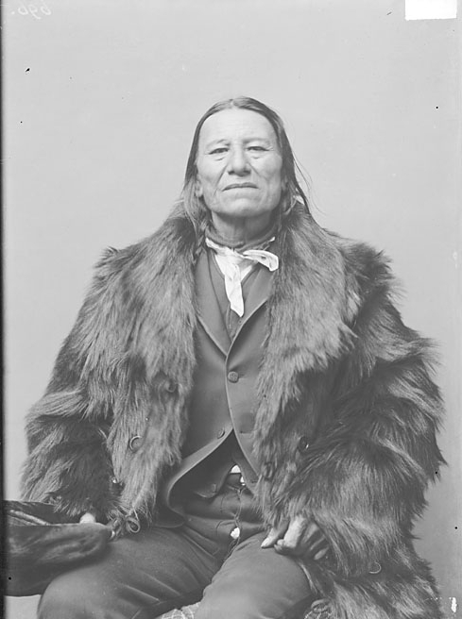

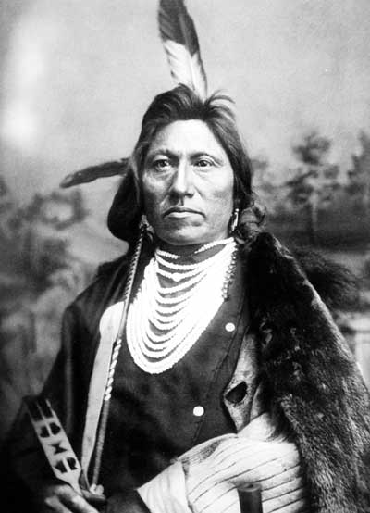

Established by in 1858
In a treaty between Yankton Band
And
United States Government
the reservation land area
is primarily, in Buffalo, Brule, Hyde and Hughes counties.

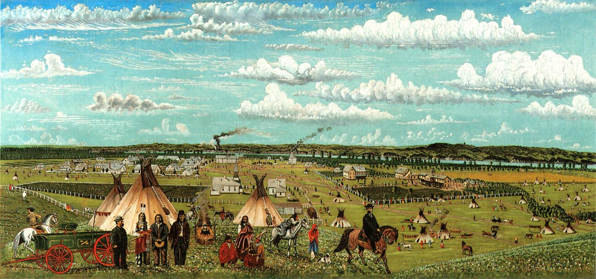

Their name was originally
The Crow Creek Sioux Tribe
And the town was originally called
The Fort Thompson South Dakota

The members are currently working on amending their constitution to officially adopt their original name of their council fires of the Dakota nation

The name Mdewakantunwan are ancestors of the 38+2 hanged in their homeland AKA Minnesota

The Dakota consider the river and Kahmi Tanka sacred..
Because they were told it is the home of sacred earth and home of the cannupa

The Christian concept
Of the devil
Is not present
In Dakota philosophy

The reservation of the tribe is located on the east bank of Missouri River which is the original territory of the Ihanktunwan & Ihanktunwanna (Yankton-Yanktonai)
Of the Dakota People

The Mdewakantunwan and Winnebago people were forcibly brought here as prisoners of war of the Minnesota War as a protection defense of the starving elder, women and children of the 1825 treaties rations being withheld and corruption of non native workers and traders of what is now called South Dakota

Since then, tribal and treaty representatives have engaged in multi agency task force to develop a plan for shelter, protection of their land and water and healthcare and cultural development goals in addition to strategies to combat continuing attacks of land and water of Crow Creek

Prior to the prisoner of war camps and reservation era
Dakota tribal societies
Were without social classes
And government was democratic
And high decentralized

An individual’s status was based
On their ability to serve and perform
And leaders existed
To serve the will of the people

Matrilineal societies played an equal role
In maintaining a nation structure
Known as the council
And prior to the reservation era
No single person was in charge of decision-making

Following the death of Wanagi Ska & Maga Bobdu the last hereditary leadership ceased to exist (per agent law)
As several bands of Isanti and Ihanktunwanna were forced to leave their homelands
Into various locations
Throughout central Dakotas

Other leaders were killed…
Deposed…or, replaced..
By those chosen by
The united states government
To act as spokesperson

Hereditary Ihanktunwanna leader Wanagi Ska was
Born about 1818
Near the headwaters
Of the Minnesota river

His father was
Bone Necklace
The leader of the Ihanktunwanna Hunkpati
Council fire

According to
The prisoner of war camp of 1863
The boundaries of the Crow Creek Reservation
Are:

“Beginning at the most

The Crow Creek Tribe
Consists of three districts
Crow Creek – 200 people
Big Bend – 100 people
Fort Thompson – 1100 people

Total enrolled members living on and off the boundaries 4544

